**LAB Education Impact 2023/24**

**Programs launched**: **MAD LAB, Adaptive Theater Workshop**

**Students Impacted**: LCCPS (10), BUSTI (45), Adaptive (12), CCSC (4-6), CAC (20) Atrium (26) City on a Hill (36)

**Venues** (Schools and Programs) partnered with/taught at: **7** (LCCPS, City on a Hill, Atrium, BUSTI, CCSC, CAC, Adaptive)

**Total Classes**/Workshops Taught: **58** (LCCPS (**4**), City on a Hill (**14**), BUSTI (**2**), CCSC (30?), CAC (**8**), Adaptive (**16**))

**Quotes**

**City on a Hill Clowning workshop 2023**

"The funniest thing was the clown noses"

"Now I have more ideas" (about movement on stage)

**"It made me open my goofy side"** -- from a more shy student; LOVE!

"It was fun when we made the funny faces"  ** (so many mentioned this as their favorite!)

"I enjoyed watching [my classmates] act together"

"It made my acting skills a lot better"

"I liked the silly things everyone did"

**"it made me think about a more humanistic type of movement"**-- WOW!

"you just act how you wanna be and also have fun while doing it"

"[the best part was] making a scene with 2 clowns because it was kind of like a freestyle."

**JCDS Shakespeare Workshop 2023**

“Teaching Shakespeare to 6th graders is hard work, but Jesse brought such energy, passion and knowledge. He was able to make the text come alive for each student by meeting each student where they were and forming trusting relationships with them. He empowered them to own their lines, their characters, and eventually their acting. Every student left the production feeling transformed as actors and students of Shakespeare thanks to Jesse's masterful leadership."- Avi Minder, 6th grade English JCDS

“Jesse's inclusive and differentiated approach in leading the 6th Grade Shakespeare Showcase is the highlight for students with neurodiverse and different learning styles. Students are made comfortable with taking risks and are so proud of themselves at the end of each show! Truly the highlight of the year!”- Jo-Ann Figueroa, Director of Support Services JCDS

“"Jesse has expanded our students' knowledge and understanding of both Shakespeare and his works, but also worked tirelessly to help students feel confident and proud in their assigned roles, which then easily transferred to their day to day lives as well. It is through theater that Jesse helps kids of all ages become their best, most accomplished selves." -Josh Mocle, Middle School Social Studies faculty

**LAB Education Impact 2024/25**

**Programs: MAD LAB, Adaptive Theater Workshop**

**Students Impacted:** LCCPS (12), BUSTI (40), Adaptive (6), CCSC (7), CAC (20), JCDS (9), Broadmeadow Elementary (60), ASDS (17), Chelmsford Library (10)

**Venues** (Schools and Programs) partnered with/taught: **9** (LCCPS, BUSTI, CCSC, JCDS, Broadmeadow, CAC, ASDS, Adaptive, Chelmsford Library)

**Total Classes/ Workshops Taught: 78** LCCPS (8), BUSTI (2), CCSC (15), JCDS (11), Adaptive (33), ASDS (2), Broadmeadow (1), CAC (5), Chelmsford Library (1)

**Quotes**

**Adaptive Quotes workshop 2024**

[Student] is planning to attend all your classes unless something comes up. He thought you were wonderful! – Parent of Student

[Student] is finding the classes joyful and useful. - Parent of student

[Student] was PUMPED last night after class and can’t wait continue after the break!- Parent of Student

Jesse piloted the theater workshop this summer with great success.- Parent of student

[Student] DEFINITELY wants to continue with Liars & Believers this fall. – Parent of Student

This is the highlight of [Student's] week! He enjoys it so !- Parent of Student

We are so grateful for this experience and all your wonderfulness!- Parent of Student

You’ve been one of the best things that happened to [Student]!- Parent of Student

Your theater group is [Students] favorite activity and has been since it got started!- Parent of Student

**CAC**

Wonderful! We are looking forward to having you here for the summer and during the winter/spring. It will be such a great opportunity to have more time with the kids to get to know each other. – Sarah Winter (Director of Programs, Community Arts Center)

**Letters from Students at CAC**

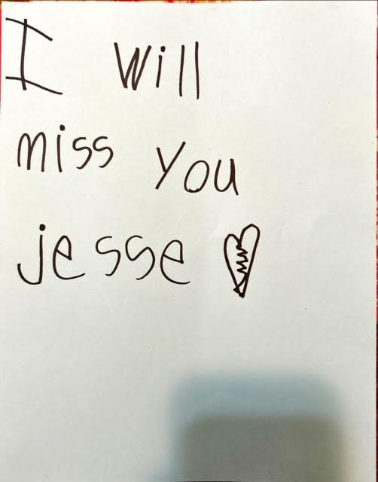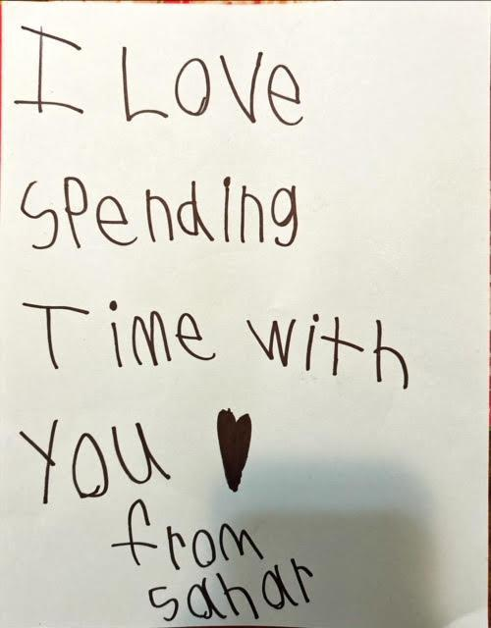

page1image2609280

**LCCPS**

"Liars and Believers gives access to theater in a fun and engaging way to a group of kids who would otherwise have limited or no exposure.  The program is critical and enriching and we are thankful to have had this wonderful experience."-**Jim Lichoulas, Head of Mill No. 5**

"We were so fortunate to have the opportunity to work with Liars & Believers. Our students cannot stop raving about the experience. We look forward to working with Liars & Believers again in the very near future!"- **Robert Gignac, COO of Lowell Community Charter Public School**

**CCSC**

“My favorite part was everything. I had fun supporting one another and I learned that I can persevere through anything through this program. I learned to be a great actor, to be confident and to be myself”- Student (12th grade)

“I loved tech rehearsal with all the lights and sound effects. Through this class I have learned that I have talent. I would definitely recommend this class to other students”- Student (10th grade)

“got of encouragement from this class. Everyone worked together and tried their best….I found confidence on stage… I would definitely recommend this class”- Student (12th grade)

“My favorite part was all the fun we had. I didn’t know I could do all that!”- Student (11th grade)

“My favorite part was learning ques…rehearsing with all these amazing actress/actors. I learned once your nervous you’re somewhat able to get through it and be stronger and improve. I learned I can be more dramatic than I was before”- Student (11th grade)

“Of course I would recommend this class! It was extremely fun”- Student (11th grade)

“Liars and Believers created a joyful, collaborative, and creative environment for our students to express themselves through theatre. The end of the year performance was a highlight -- several of our school's quieter students had starring roles, and delivered an outstanding performance in front of students, staff, and families.”- Jeff Vogel, Director of Curriculum and Instruction